- One Method

- Csv file – this is our source file
- SQl server management studio-we will use its inbuilt import wizards to transform and load data
- SQl server dashboard – this is where our final data will be loaded and host our data warehouse, tables, and views for final uses

- Alternative methods

- Csv file - this is our source file
- SQl server integration services – we can use custom -made SSIS packages to transform and load data. this is usually used when you have recurring data loads and you want to automate the process
- SQl server database – packages load our final data into data ware house in SQl server

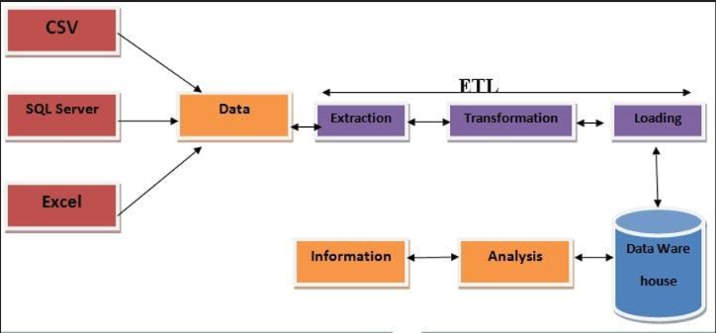

CSV Source File
(Raw Business Data)
↓
Extraction Layer
(SQL Server Management Studio
Import Wizard / SSIS Packages)
↓
Staging & Transformation Layer
(Data Validation, Cleansing,
Mapping, Business Rules)
↓
Load Layer
(SQL Server Database
Data Warehouse)
↓
Reporting & Analytics
(Dashboard, Reports,
Business Users)

